Training material

Osek/VDX Operating System

author: Thomas Staebe, Schleißheimer GmbH

Content

Content 2
1 OSEK 3
2 Objects in OSEK-OS 4
3 Tasks 5
3.1 States of tasks (Basic-Task) 6
4 Scheduling 8
4.1 Preemptive / Nonpreemptive 8
4.1.1 Nonpreemptive scheduling 9
4.1.2 Preemptive Scheduling 10
4.1.3 Mixed-preemptive scheduling 10
5 Interrupts (Cat. 1/2) 11
6 Services calling 12
7 Alarms 13
8 Events 14
8.1 States of tasks (Extended-Task) 15
8.2 Events in non-preemptive scheduling 16
8.3 Events in preemptive scheduling 16
9 Ressourcen 17
9.1 Influence of resources on the priority of tasks 18
10 Semaphore 19
10.1 Additional task states using semaphore 20
10.2 Behavior of several tasks 21
10.3 Priority inverting by using of semaphore 21
10.4 Deadlock 22
11 Hooks 23
12 OIL-Tool, OIL-File 24
12.1 Snippets of the oil-File: 25
12.2 Snippets of the tcb.h file: 27
13 WOsek 29
13.1 Snippets of a WOsekConfig.h file 29
14 Exercises 31
14.1 Generating tasks 31
14.2 Defining task‘s order 31
14.3 Starting a higher prioritized task 31
14.4 Synchronizing access to data 31

OSEK

OSEK is a industrial standardization council. The name OSEK is composed of
"Offene Systeme und deren Schnittstellen für die Elektronik im Kraftfahrzeug" (open systems and their interfaces for the automobile’s electronic system).

OSEK was founded in 1993 and different automotive manufacturer and their software suppliers are in. Founding members are:
BMW AG,
Daimler-Benz AG (heute Daimler AG),
Adam Opel AG,
Volkswagen,
Robert Bosch GmbH,
Siemens AG
Institut for industrial information systems of Universität Karlsruhe (TH).

In 1994, the French Council called VDX connected to OSEK and the members of VDX like Peugeot, Citroën, Renault became members of OSEK.
Since the official label is OSEK/VDX. The founder members form the Steering Committee till this day.

The OSEK can be split into the following parts:
OSEK-OS: The actual operating system (topic of this class).
OSEK-COM: Definition of communication systems for example CAN.
OSEK-NM: Network management.
(further parts see http://portal.osek-vdx.org/)

Links:
Website: http://portal.osek-vdx.org/.
Specification: Z:\Projekte\Spezifikationen und Normen\OSEK\OSEK OS\os223.pdf .

Objects in OSEK-OS

OSEK-OS defines and deals with the following objects:

Tasks: A task is a exercise that the operating system can run quasi parallel to other tasks. The processing order follows a priority order.

Interrupts: Interrupts interrupt the actual task, because there is something more important to do like for example replying on Hardware demands.

Alarms: Another word for Alarm is egg timer. So alarms trigger something after a certain time.

Resources: Resources are things that several tasks struggle for. A resource that is hold by a task increases the task’s priority level.

Events: Events stop tasks at a defined point to process anything else. After occurring and processing an event the task run on at its stop point.

Semaphores: Interlocking of tasks
Hooks: Functions that are called by certain events from the operating system.

Tasks

- A task is a kind of function that can be called by the operating system.
- Every task has a priority that is determined during the compiling process.
- The processing order follows a priority order.
- A task is able to become different states.
- The task’s processing routine can be interrupted and run on again.
- The code shows a task as a function.

Example:

#define TASK(x) void x##func(void)

TASK(CAM_10ms)
{
static uint8 u8Wert = 0;
u8Wert += 1;
TerminateTask();
}

States of tasks (Basic-Task)

There are two kinds of tasks:
- Basic-Tasks
- Extended-Tasks

For now in this section the focus is on the Basic-Tasks. The Extended-Tasks are discussed in the next section together with the events.

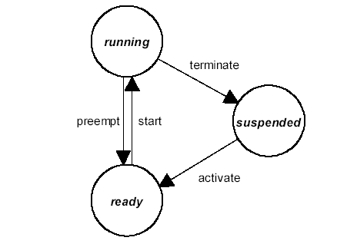

transition | state before | new state | description
activate | suspended | ready | The call ActivateTask( TaskID ) activates a task. The operating system starts a task depending on the priority order. If a task was started the process begin at the first code row of the task function.
start | ready | running | The operating system has decided to run a task and starts it now.
terminate | running | suspended | The task function has decided to terminate the task. A task can only be terminated by itself.
preempt | running | ready | The operating system has temporary decided to run another task. The actual task is interrupted and starts again at the position that the task has left.

Explanation:
- The task function must ends with TerminateTask(). Without a terminate expression a OSEK-Exception is triggered and maybe even a reset is started depending on the system configuration.
- The call of ActivateTask() does not mean absolutely that the task will be started. The operating system decides to start a task by the priority order of all running and waiting tasks.
- The preemt transition occurs only in preemptive systems (informations comes further)
- Depending on the configuration a task can be activated only once or several times. But a task can expired only once at a defined time point. And a task can be instanced only once.

Commands:
ActivateTask( TaskID )
TerminateTask()
ChainTask( TaskID )
GetTaskID( *pTaskID )
GetTaskState(TaskID, *pState )
Schedule()

Scheduling
Scheduling describes the order in which tasks will be processed. So the processing order is decided by the “scheduler”.
The scheduling process should be explained by this example:
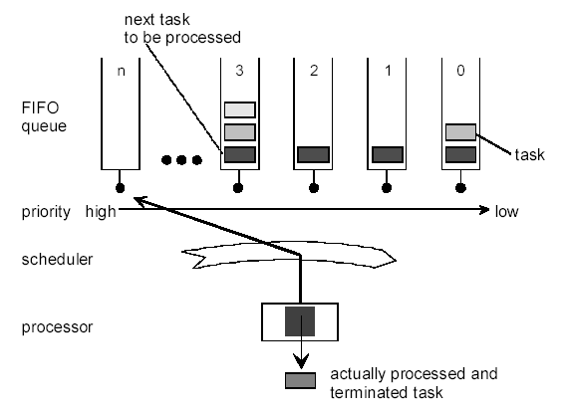

Activated tasks are sorted by their priority in queues. First the scheduler looks into the queue with the highest priority. If this queue is empty the scheduler goes to the next decreasing queue till it points the queue with the lowest priority (e.g. 0).
If there are several active tasks in a queue, a task will come first that came as first in the queue, too (FIFO). If a task is terminated or interrupted, the scheduler will look for a new task to start as the same as before.

Preemptive / Nonpreemptive
Basically there are two kinds of scheduling polices:
- Preemptive
- Nonpreemptive
Preemptive systems will interrupt a task, if the task has a higher priority than the running task. Nonpreemptive systems does not interrupt running tasks.

OSEK System has not got a time slice controlling as it Windows has. In Windows, tasks with lower priority got some computation time although there were never leveled with highest priority.
Against this, OSEK starts never tasks with lower priority!

Nonpreemptive scheduling
Nonpreemptive systems does not interrupt running tasks. A task always runs till it is terminated (TerminateTask() )or become a waiting task (WaitEvent()).
There is the possibility to interrupt a task, if the task calls the scheduler by itself.

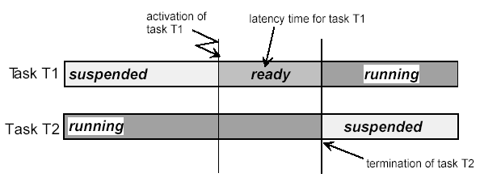
nonpreemptive scheduling

Explanation:

- Task T2 is executed, task T1 is suspended
- Task T2 activates the higher prioritized task T1. T1 goes in the ready state and wait on a start expression. T1 will not be interrupted.
- Even if Task T2 terminates by itself, the scheduler will be looking for a new ready task and find task T1. Only now T1 is started.

Preemptive Scheduling
Preemptive Scheduling will interrupt a task, if the task has a higher priority than the running task. The running task is set to ready state. If all higher prioritized tasks are processed, the original task that was set to ready will start on at the position it was interrupted. The interrupted task does not know that it was interrupted.

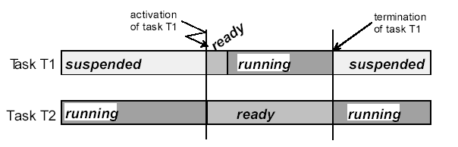
(full) preemptive scheduling

Erläuterungen:
- Task T2 runs, task T1 is suspended.
- Task T2 activates the higher prioritized task T1. T1 goes into ready state. The Scheduler is started und is looking for the task with the highest priority. Task T1 is highest one. Task T1 starts immediately. T2 is interrupted and set to ready state.
- If task T1 terminates by itself, the scheduler will looking for an new task and find task T2 again. Now T2 starts at the point that it was interrupted by T1 and the scheduler.

Mixed-preemptive scheduling
If the system is mixed-preemptive scheduling, you can control a task should be or should not be interrupted.

Interrupts (Cat. 1/2)

OSEK supports two kinds of interrupts:
- Category 1
- Category 2

The difference between them is that category 2 Interrupts are synchronized with the internal controlling by OSEK. In order to that calling the OSEK-Services regarding to category 2 Interrupts are allowed.

For category 1 interrupts it is forbidden. Therefore the latency time for catefory 1 is shorter than for category 2 interrupts.

In the OSEK specification, Category 2 interrupts can be sorted into the task container depending on their priority and delayed by higher prioritized tasks.
(But that is not possible in the Vector implementation that is use by VDO.)

OSEK offers services they can suspend and release interrupts. Those should be preferred in OSEK systems instead of “normal” “DI”- und “EI-commands”. The OSEK services offer additional mechanisms for monitoring the interrupt locks and enable nesting of interrupt locks.

Commands:
void EnableAllInterrupts () //No Nesting
void DisableAllInterrupts () //No Nesting
void ResumeAllInterrupts () //Nesting is allowed
void SuspendAllInterrupts () //Nesting is allowed
void ResumeOSInterrupts () //Nesting is allowed
void SuspendOSInterrupts () //Nesting is allowed

Services calling

If a service call is allowed in a certain context, will show the following table:
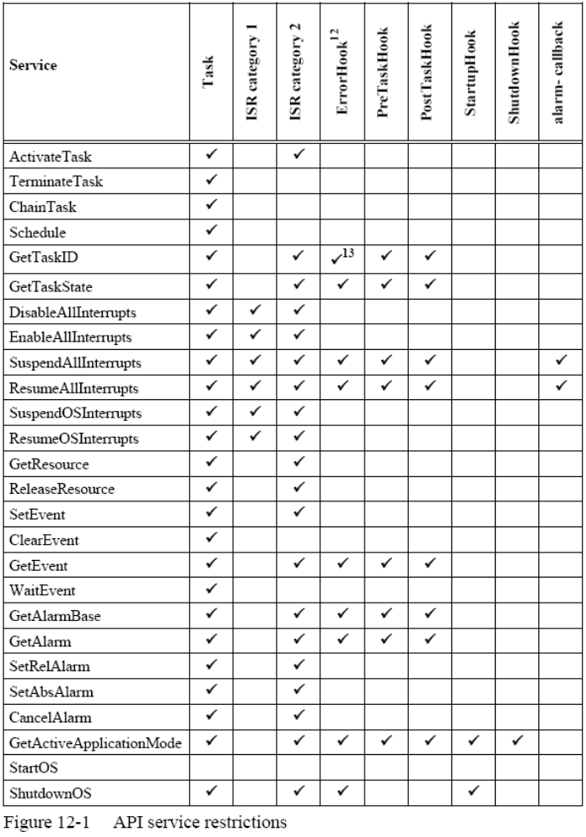

Alarms

Another word for Alarm is egg timer. So alarms trigger something after a certain time:
- Alarms are able to activate tasks (no start)
- Alarms are able to set events (see chapter “Events”)
- Alarms are able to call Callback functions.

Alarms are used to activate tasks for the most time. These tasks take part in the scheduling process and are started if there are no higher prioritized tasks in ready state.

Naturally, starting callbacks is faster than starting tasks, but callbacks do not allow calling further OSEK-Services with the exception of interrupt locks.

Alarms are connected to counter and trigger a alarm if a certain counter reading state is reached. By what these counter are driven is unknown. Therefore are alarms

Alarme hängen an Zählern und werten deren Zählerstand aus. Wenn ein bestimmter Zählerstand erreicht ist, wird der Alarm ausgelöst. That is why alarms are not only limited to time. Theoretically alarms are able to trigger by position instead of time. For example an incremental position decoder is connected to a counter and the counter will trigger an event, if a certain number of pulses ocurr.

During “pulling” an alarm you can decide whether the alarm should observe the absolute counter value or set the counter value as the difference of the pulling before.

Commands:
SetAbsAlarm( AlarmID, TicksStart, TickCycle )
SetRelAlarm( AlarmID, TicksIncrement, TickCycle )
CancelAlarm( AlarmID )
GetAlarm( AlarmID, *pTicks )

Events

An event can be thought of as 1-Bit information. Events are linked to certain tasks. Every task has got its own events. But only extended tasks can own events.

- An extended task can wait for event’s set.
- A task (basic or extended) can set events.
- A task (basic or extended) can request a event’s state.
- An extended task can reset its own events.

- If a task has got a resource, the task must not wait for a event. It will be forbidden to call WaitEvent(), if a task has got a resource.

Commands:
WaitEvent( Event )
SetEvent( TaskID, EventMask )
ClearEvent( Event )
GetEvent( TaskID, EventMask )

States of tasks (Extended-Task)
Extended events need the new state „waiting“ having the ability to wait for a new state.

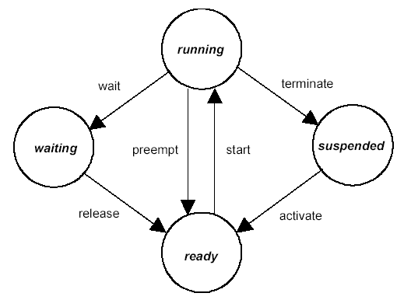

Transition | State before | New state | Explanation
wait | running | waiting | The task has called WaitEvent() and the event that the task is waiting for is not set. By that the task goes into “waiting” state. The task stays in the function WaitEvent().
release | waiting | ready | Another task or a alarm has set the event that the actual task is waiting for. Than the task goes into the “ready” state. When the task is restarted, than it will begin running at the position where it was stopped. In other words the task return from WaitEvent() as it has been nothing happen. There are no effects on the actual task process by calling WaitEvent().

All other transitions are the same as basic tasks.

Events in non-preemptive scheduling

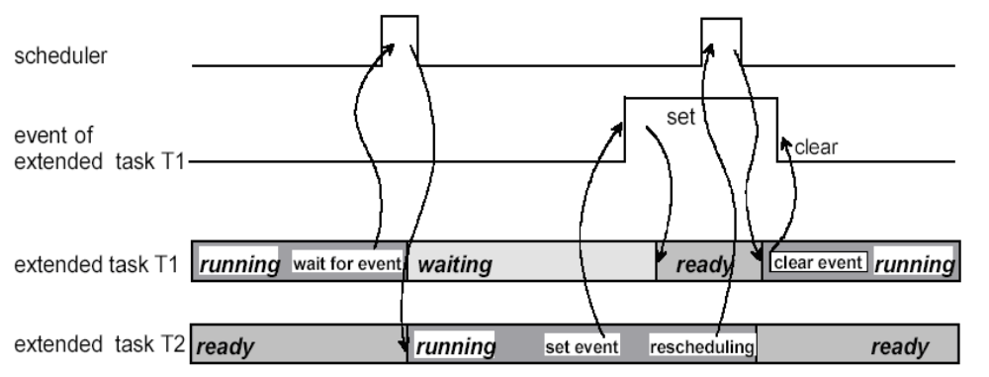

Events und non preemptives Scheduling

- Task T1 is running and is reaching WaitEvent() in the code. The event is not set and the task stops.
- Task T2 starts
- Task T2 sets the event ("SetEvent( )") and task T1 which observe that event goes into “ready” state.
- Task T2 activates scheduling (Schedule()) and is stopped by the higher prioritized task T1. T1 starts.
- Task T1 is calling "ClearEvent( )" to delete the event for the next time.

Events in preemptive scheduling
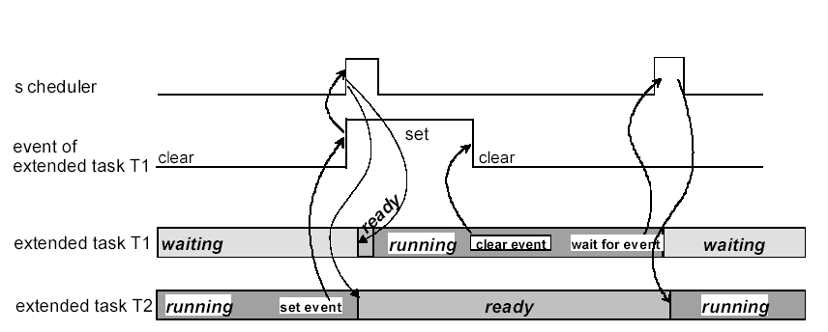

Events und (voll) preemptives Scheduling

- Task T1 is waiting on a event.
- Task T2 sets that event
- Because of the system is working preemptive and the task T1 is higher prioritized than T2, T2 is interrupted and T1 is started.

Ressourcen

- Resources are things that several tasks struggle for, but only one task can hold a resource for a time.
- If a task want to use a resource, than it must take the resource. A resource that is hold by a task increases the task’s priority level. By this way other tasks having no resource are not able to start. So the task with the resource cannot be interrupted by other tasks wanting that resource, too.
- A resource can be seen as a priority push that a task get when it keeps the resource.
- If a task release a resource, the task’s priority will be decreased on the „normal“ level and can be interrupted by other tasks those the resource need.
- Resources are distinguished into internal and external resources. External resources have to be requested from tasks. Internal resources will be automatically allocated when they are started.

- There is a special resource („RES_SCHEDULER“). These resource rise up a task’s priority level, so that the scheduler of OSEK cannot be started anymore. With that resource the scheduler becomes out of order for that time the resource is hold by a task.

Commands:
GetResource( ResID )
ReleaseResource( ResID )

Influence of resources on the priority of tasks

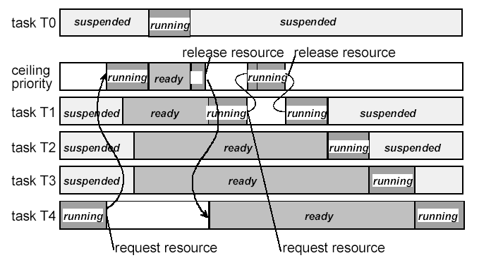

Explanation:
- Task T4 pulls the resource and its priority exceeds the priorities of the tasks T3, T2 and T1.
- Task T1, T2 and T3 are activated, but cannot be started, because of task 4 priority.
- Task T0 becomes active, because its priority is above the resource’s one. Task 4 is going to be interrupted for the runtime of task 0. If task 0 ends, task4 will start.
- Task T4 release the resource. Therefore its priority decreases under T3. Task T4 is interrupted and the task with the highest priority(e.g. task T1) is started.
- Task T1 pulls the resource and has got the highest priority.

Semaphore

- Semaphore do not belong to the OSEK-Standard respectively they are explicit excluded in the OSEK specification of the OSEK-consortium, because it can cause negative effects like priority inverting or deadlocks. However, semaphores were implemented in the OSEK-System, due to the wishes of some OSEK user (VDO).
- A semaphore is something like a „critical section“ from the Windows Programming. If a task has entered a semaphore, other tasks are not able to get the same semaphore.
- Semaphore can only be used in extended tasks.
- A task that cannot get a semaphore, because the semaphore already has been entered by another task, will be set into waiting state by OSEK (similar to events). Than the task remains in the function call of GetSemaphore().
- If the semaphore becomes free again, a task that is waiting on the semaphore will be set to “ready“ state. The task can be restarted by OSEK. If it was restarted, than it will automatically enter the semaphore.
- If several tasks are waiting for a semaphore, than the task with the highest priority will set to ready state during releasing semaphore.
- If a task hold a resource, than it will not be allowed to request a semaphore.

Commands:
GetSemaphore( SemaphoreID )
ReleaseSemaphore( SemaphoreID )

Additional task states using semaphore

s

Transition | State before | New State | Explanation
get_semaphore | running | wait_semaphore | The task has called GetSemaphore(). But another task has already reserved the semaphore. So the task transit into the state “wait_semaphore” and stays in the function GetSemaphore().
Semaphore_free | wait_semaphore | ready | The other task having reserved the semaphore before has released it. By that the task goes into ready state. If it is restarted again, it will begin at the position where it has left. The task returns out of the function GetSemaphore(). It has left the semaphore, but do not take notice of the semaphore process.  Der andere Task, der die Semaphor zuvor besessen hat, hat diese wieder freigegeben. Dadurch wird der Task wieder in den "ready"-Zustand gesetzt. Wenn er wieder gestartet wird, läuft er genau an der Stelle weiter, an der er angehalten wurde. D.h. er kehrt aus der Funktion GetSemaphore() zurück. The task has entered the semaphore. The task does not notice of waiting for the semaphore.

All other transitions are described as before.

Behavior of several tasks
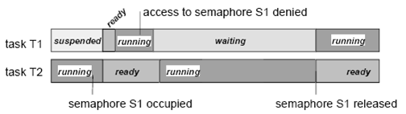

Explanation:
- Task T2 enters semaphore S1
- Task T1 is activated, due to the higher priority than T2, T2 is interrupted and T1 is started
- Task T1 want to enter semaphore S1, but is not possible to do, becausse T2 already reserve S1. Task T1 is set to "wait_semaphor". Task T2 can run on, now.
- Task T2 exits the semaphore. Task T1 gets the semaphore and runs.

Priority inverting by using of semaphore

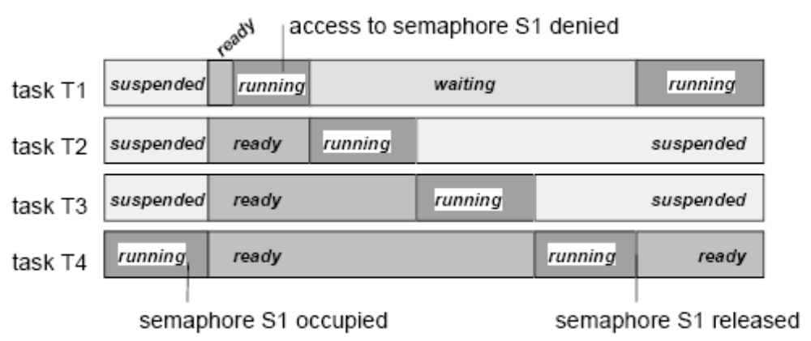

Explanation:
- Task T4 is running and occupies semaphore S1.
- The tasks T1, T2, T3 becomes active, because they are higher prioritized than T4. T1 is running.
- T1 try to access to semaphore S1, but the system denies, because S1 is occupied by T4. T1 goes into waiting state and even T2 and than T3 are running.
- After that T4 is running and release its semaphore S1 when it has finished. T1 gets S1 and is running.

Deadlock

Deadlocks occur when at least two tasks want to enter cross-over at least two semaphore:

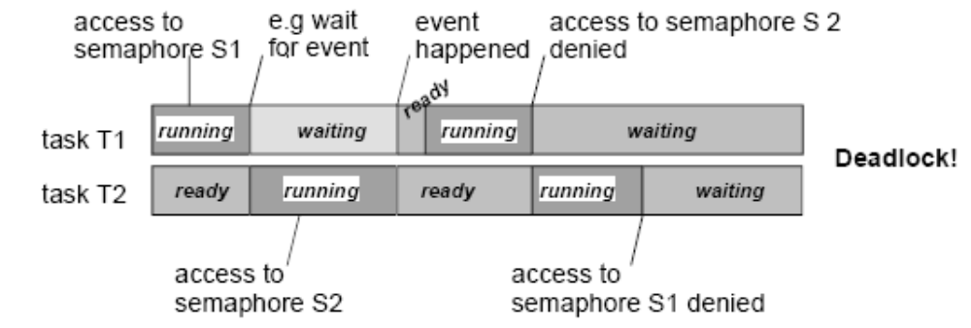

- Task T1 runs and enters semaphore S1.
- Task T1 have to wait on an event, so that task T2 gets restarted.
- Task T2 enters the Semaphore S2.
- Task T1 get set its event and can run on. T2 is interrupted.
- Task T1 want enter S2, now, but S2 is reserved by T2. Task T1 have to wait. T2 can run on.
- Task T2 want enter the semaphore S1 which is reserved by T1. Now both tasks are waiting for the release of the semaphore of the respective other task. Both wait, but no task will release its semaphore. This state will not change. The system hangs. -> Deadlock

Hooks
Hooks are Callback functions that are called by OSEK when certain events occur. Hooks can be used to debug or trace of OSEK OS workflow, for runtime measurements or general purposes.

The following hooks can be used:
StartupHook() is called by OSEK after OSEK OS was initialized and before any actions are executed.

ShutdownHook() is called before the system will be shut down. It is the last action of the OSEK.
PreTaskHook() is called before a task is started. The current task is already the new one that begins after the hook.

PostTaskHook() is called when a task stops to run regardless of whether it was terminated or interrupted. The current task is that one having just run now.

PreAlarmHook() is called before a alarm action is executed.

OIL-Tool, OIL-File

There is a own language for configuring the OSEK OS: The “OSEK Implementation Language” (short: “OIL”). Here, all OSEK objects (e.g. tasks, events, interrupts, etc.) and system settings (e.g. system timer, scheduling policy) are configured. Those settings are saved in the format *.oil-File . By the so called OIL-Tool, it is possible with the input of the *.oil-File to generate the source files for the configuration of the OSEK system.

User-interface of the OIL-Tool:

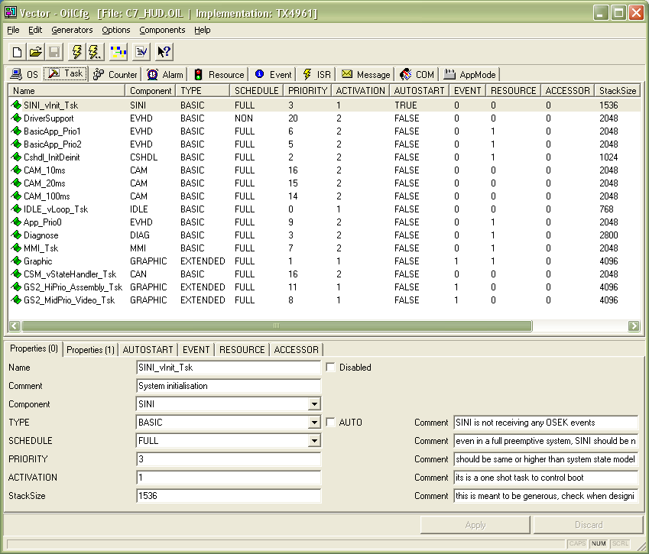

Snippets of the oil-File:

OS C7_HUD {
STATUS = EXTENDED;
SCHEDULE = AUTO;
ERRORHOOK = TRUE;
SHUTDOWNHOOK = FALSE;
PRETASKHOOK = FALSE;
POSTTASKHOOK = FALSE;
CpuFrequency = 240.000000;
SystemTimer = _24Bit_SystemTimer;
UseSemaphores = TRUE
{
Semaphore = "GS2__osSem_LoHiPrio_Tsk";
};

TASK SINI_vInit_Tsk {
Component = "SINI";
TYPE = BASIC;
SCHEDULE = FULL;
PRIORITY = 3;
ACTIVATION = 1;
AUTOSTART = TRUE;
StackSize = 1536;
}

TASK BasicApp_Prio1 {
Component = "EVHD"
TYPE = BASIC;
SCHEDULE = FULL;
PRIORITY = 6;
ACTIVATION = 2;
AUTOSTART = FALSE;
RESOURCE = RES_DiaLockApp_Prio1;
StackSize = 2048;
};

TASK CAM_10ms {
Component = "CAM";
TYPE = BASIC;
SCHEDULE = FULL;
PRIORITY = 16;
ACTIVATION = 2;
AUTOSTART = FALSE;
StackSize = 2048;
NotUsingSchedule = FALSE;
UseFPU = FALSE: "unknown";
}: "RM_hRT";

ALARM CAM_10ms_Alarm {
Component = "CAM";
COUNTER = SystemTimer;
ACTION = ACTIVATETASK
{
TASK = CAM_10ms;
};
AUTOSTART = FALSE
{
StaticAlarm = FALSE;
};
};

RESOURCE RES_DiaLockApp_Prio1 {
Component = "Main Component";
RESOURCEPROPERTY = STANDARD;
};

EVENT GOSW__osEv_GA_Rdy {
Component = "Main Component";
MASK = AUTO;
};

ISR SPI_vRxFillLevel0_ISR {
Component = "ASYNCIO";
CATEGORY = 2;
Type = Interrupt
{
InterruptNumber = 43;
InterruptLevel = 4;
UseFPU = FALSE;
};
UseSpecialFunctionName = FALSE;
};

ISR POWB_vUV1_Isr {
Component = "POW;
CATEGORY = 2;
Type = Interrupt
{
InterruptNumber = 1: "INT0";
InterruptLevel = 7;
UseFPU = FALSE;
};
UseSpecialFunctionName = FALSE;
}: "POWB";

The most important generating code file from the OIL-Tool ist the “tcb.h” file. Here, all ID’s are defined in the OSEK object. This file is automatically included when “osek.h” is included.

Snippets of the tcb.h file:

#define osdNumberOfAllTasks 16
#define osdNumberOfBasicTasks 13
#define osdNumberOfExtendedTasks 3
#define osdNumberOfPriorities 18
#define osdNumberOfAllResources 4
#define osdNumberOfTaskResources 4
#define osdNumberOfAlarms 3

#define GOSW__osSem_GADCtrlCapx ((SemaphoreType) 0)
#define GOSW__osSem_GADFramework ((SemaphoreType) 1)
#define GS2__osSem_LoHiPrio_Tsk ((SemaphoreType) 2)
#define osdNumberOfSemaphores 3

#define osdSystemTimer osd_24Bit_SystemTimer

#define osdSystemStackSize 2048

/* Tasks */
#define GS2_HiPrio_Assembly_Tsk ((TaskType)0)
#define GS2_MidPrio_Video_Tsk ((TaskType)1)
#define Graphic ((TaskType)2)
#define DriverSupport ((TaskType)3)
#define CAM_10ms ((TaskType)4)
#define CSM_vStateHandler_Tsk ((TaskType)5)
#define CAM_20ms ((TaskType)6)
#define CAM_100ms ((TaskType)7)
#define App_Prio0 ((TaskType)8)
#define MMI_Tsk ((TaskType)9)
#define BasicApp_Prio1 ((TaskType)10)
#define BasicApp_Prio2 ((TaskType)11)
#define SINI_vInit_Tsk ((TaskType)12)
#define Diagnose ((TaskType)13)
#define Cshdl_InitDeinit ((TaskType)14)
#define IDLE_vLoop_Tsk ((TaskType)15)

/* Resources */
#define RES_StateHandler ((ResourceType)0)
#define RES_DiaLockApp_Prio1 ((ResourceType)1)
#define RES_GraficLockApp_Prio2 ((ResourceType)2)
#define RES_SCHEDULER ((ResourceType)3)

/* Events */
#define GOSW__osEv_GA_Rdy ((EventMaskType)(0x01))/* AUTO */

/* Alarms */
#define CAM_10ms_Alarm ((AlarmType)0)
#define CAM_20ms_Alarm ((AlarmType)1)
#define CAM_100ms_Alarm ((AlarmType)2)

/* ISRs */
#define osdIsrEXEA_vIllegalOpcode_IsrCat 1
#define osdIsrTIMD_vT20CMP1Cat 2
#define osdIsrSPI_vRxFillLevel0_ISRCat 2
#define osdIsrSPI_vTxFillLevel0_ISRCat 2
#define osdIsrCAND__vTXCANRx0_IsrCat 2
#define osdIsrCAND__vTXCANTx0_IsrCat 2
#define osdIsrCAND__vTXCANErr0_IsrCat 2
#define osdIsrADC_vConversion_IsrCat 2
#define osdIsrPOWB_vUV1_IsrCat 2
#define osdIsrGAD__vCapMFG_IsrCat 2

osqROM0 extern osTaskFctType osqROM1 const osqROM2 osqROM3
oskTcbTaskStartAddress[1];
osqROM0 extern osStackPtrType osqROM1 const osqROM2 osqROM3
oskTcbStackTop[osdNumberOfAllTasks];
osqROM0 extern osStackPtrType osqROM1 const osqROM2 osqROM3
oskTcbStackBottom[osdNumberOfAllTasks];

WOsek

WOsek is a OSEK OS Implementation based on Win32/MFC. It is used for WinECU in order to run target code for instrument cluster projects on a windows PC.

- The WOsek has the same behavior as the OSEK OS on a microcontroller for observations on scope of milliseconds.
- OSEK tasks are emulated by Windows threads.
- Interrupts are emulated as tasks.
- The system configuration is performed by preprocessor macros in a file named “WOsekConfig.h” instead of OIL-File/OIL-Tool.

Snippets of a WOsekConfig.h file

// Kennungen bzw. Bitpositionen einzelner Events
enum Events
{
EVHD_Graphic_ContextSwitch = 0x01,
GOSW__osEv_GA_Rdy = 0x02
};

/************************************************************/
/* */
/* ACHTUNG: */
/* Die komplette Konfiguration ist _ein_ Makro! */
/* Bitte darauf achten, dass am Ende jeder Zeile ein */
/* \ (Backslash) steht. */
/* */
/************************************************************/
/*MakeOsekConfiguration start of macro */
#define MakeOsekConfiguration \
\
MakeOs( OS_MIXEDPREEMPTIV ) \
\
/*Counter \
Name MaxValue TicksPerBasectiv MinCycle \
----------------------------------------------------------*/\
MakeCounter( SystemTimer, 0xFFFF, 1, 1 ) \
\
/*Ressourcen \
Name/ID Prio Bemerkung \
----------------------------------------------------------*/\
MakeResource( IRQ_SPERRE, 255 ) \
MakeResource( RES_SCHEDULER, 250 ) \
MakeResource( RES_Graphic, 250 ) \
\
/*Interrupts \
Name/ID Prio Resource \
----------------------------------------------------------*/\
MakeIsr( ADC_vConversion_Isr, 240, NoOsekResource ) \
MakeIsr( CAND__vTXCANRx2_Isr, 240, NoOsekResource ) \
MakeIsr( CAND__vTXCANTx2_Isr, 240, NoOsekResource ) \
MakeIsr( POWB_vUV1_Isr, 240, NoOsekResource ) \
MakeIsr( POWB_vUV2_Isr, 240, NoOsekResource ) \
MakeIsr( SSSA__vRxFillLevel0_ISR, 240, NoOsekResource ) \
\
/*Tasks \
Name/ID Prio Activ Resource Typ \
----------------------------------------------------------*/\
MakeTask( CAM_100ms, 13, 2, NoOsekResource, \
TASK_TYPE_BASIC | TASK_TYPE_MULTIREQ )\
MakeTask( GS2_ANIM_HiPrio_Tsk, 18, 1, NoOsekResource, \
TASK_TYPE_EXTENDED | TASK_TYPE_PREEMPT )\
MakeTask( SINI_vInit_Tsk, 4, 1, NoOsekResource, \
TASK_TYPE_BASIC | TASK_TYPE_INITSTART )\
MakeTask( IDLE_vLoop_Tsk, 0, 1, NoOsekResource, \
TASK_TYPE_BASIC | TASK_TYPE_PREEMPT )\
MakeTask( IOQHA_vQhandle_Tsk, 9, 3, NoOsekResource, \
TASK_TYPE_BASIC | TASK_TYPE_MULTIREQ )\
----------------------------------------------------------*/\
\
/*Alarme \
Name/ID CounterID Task Callbackfunktion Events \
----------------------------------------------------------*/\
MakeAlarm( CAM_100ms_Alarm, SystemTimer, \
CAM_100ms, NoCallback, NoOsekEvent )\
MakeAlarm( SSSA_Timer0, SystemTimer, \
SSSA_vTimeoutCh0, NoCallback, NoOsekEvent )\
\
/*Semaphoren \
Semaphor_ID \
----------------------------------------------------------*/\
MakeSemaphore( GOSW__osSem_CS1 ) \
\
/*Hooks \
Name_ID Callback \
----------------------------------------------------------*/\
MakeHook( OS_STARTUPHOOK, StartupHook )\
MakeHook( OS_ERRORHOOK, ErrorHook )\
MakeHook( OS_PRETASKHOOK, vPreTaskHook_Block_Background )\

/*MakeOsekConfiguration end of macro */

Exercises

Generating tasks
Three tasks (task1, task2, task3) should be created. Every task nee a certain amount of time before a task is finished. (Wait-Funktion)

Defining task‘s order
Three tasks (task1, task2, task3) should be started and finisched in alphabetic sequence.
- All tasks have the same priority in a non-preemptive system. Integrate a ResetTask that starts the system.
- Reverse the activation order against the Execution order. (Priority does not matter)

Starting a higher prioritized task

A higher prioritized task should be started from a task with a lower priority.
a) The higher prioritized task should be executed as fast as possible.
b) The running task must not be interrupted in a full preemptive system!

Synchronizing access to data
- A cyclical task and a free running task read the same data (timer1, timer2, timer3).
- The free running task increments all three counter
- The cyclical task proves, if all three counter have always the same level.

It should never happen that the counter levels are different in the cyclical task.
- There are only those both tasks in the system. The solution should be easy and fast as possible.
- Existing tasks must not be delayed unnecessary.

